Identifying Unique Phenotype Clusters in Diabetes Type 2 using NHANES
Mike Anderson
Whiting School of Engineering, Johns Hopkins University Baltimore, MD, USA

Abstract—Diabetes Mellitus Type 2 is a pervasive, global metabolic disorder characterized by either a person’s inability to produce adequate insulin or a person’s resistance to insulin, leading to the inability to metabolize glucose effectively [1]. Because of this, people with Diabetes Type 2 are at a higher risk of developing complications related to liver, heart, and kidney function, with disorder severity levels differing widely, making treatments inherently different based on the symptoms presented and observed. This study seeks to understand the underlying phenotype sub-groups of Diabetes Type 2 by utilizing Uniform Manifold Approximation and Projection (UMAP) and Gaussian Mixture Models (GMM) to better inform physicians and researchers as it relates to prognosis, patient care, and drug discovery. While Ahlqvist et al. [2] showed that diabetes is a heterogenous disease, the study was limited to using biochemical features and didn’t utilize any demographic or lifestyle metrics. This study extends the work of Ahlqvist et al. by incorporating lifestyle, demographic, and additional laboratory biomarker features. Using UMAP and GMM, seven stable phenotypic clusters were identified in the United States using the NHANES database, including two novel clusters (physical activity and hepatic elevation) not previously described in diabetes clustering literature.
Keywords—diabetes, mellitus, type 2, phenotype, sub-group
I. Introduction
Diabetes mellitus is a group of metabolic disorders in which glucose is both underutilized and overproduced due to inappropriate gluconeogenesis and glycogenolysis, resulting in hyperglycemia. Type 2 diabetes is classified based on nonautoimmune progressive loss of adequate β-cell insulin secretion, frequently on the background of insulin resistance [1]. The standard tests for diabetes diagnosis are the A1C and plasma glucose tests, the former of which is used to determine a diabetes diagnosis for this study.
According to the United States’ Centers for Disease Control and Prevention (CDC), approximately 40.1 million Americans, or 12% of the population of the United States, have either diagnosed or undiagnosed diabetes. Of those with diabetes, 90-95% have Type 2 diabetes, making it an epidemiological imperative for research and treatment development [3].
Originally, Type 2 diabetes was treated as a monolithic disorder with rigid treatment plans for the entire spectra of symptom presentations. However, Ahlqvist et al. (2018) found that there were sub-groups within Type 2 diabetes, leading to researchers and practitioners developing targeted treatment options based on a given patient’s biological subtype [2][4].
Chung et al. (2020) also advocated for the use of precision diagnosis and treatments in 2020, further advancing the need to understand and research sub-types of diabetes [4]. Simple classification using biometric cutoffs were deemed inefficient and were not associated with any meaningful clinical outcomes [5].
This paper attempts to expand upon the findings of Ahlqvist et al. (2018) by utilizing both biometric and self-reported statistics of individuals using the CDC’s NHANES database to further examine the sub-phenotype phenomena and determine if there are additional sub-types of Diabetes Type 2 within the United States’ population.
II. Related Work
Ahlqvist et al. (2018) marked the first research into the sub-phenotype phenomena as it relates to diabetes, utilizing the Swedish All New Diabetics in Scania cohort and performing k-means and hierarchical clustering to determine the subgroups. Using six variables (glutamate decarboxylase antibodies, age at diagnosis, BMI, HbA1C (A1C), and estimates of β-cell and insulin resistance, they were able to determine that there were five replicable clusters that had statistically significant characteristics and complication risks [2].
Chung et al. (2020) advocated for precision diagnostics and treatments in diabetes, citing that inadequately understanding and identifying the diverse phenotypes associated with diabetes could limit disease prevention and treatment [4].
Misra et al. (2023) furthered the need for advanced analytical methodologies in diabetes by performing a systematic review of 51 studies, ultimately determining that simple classification utilizing cutoffs and other simple metrics were not sufficient to improve clinical outcomes and that advanced methodologies relating to data science and machine learning are needed [5].
III. Methods
A. Data Collection and Processing
Data was collected from the Centers for Disease Control and Prevention (CDC)’s National Health and Nutrition Examination Survey (NHANES) for the 2021 to 2023 cohort, consisting of 11,933 respondents ranging in age from 0 to 80 (top-coded), both males and females. Of those, 6,715 respondents had valid glycohemoglobin test results and 3,672 respondents had valid fasting plasma glucose tests.
Of the total respondents with valid glycohemoglobin (A1C) or fasting plasma glucose tests, 837 respondents met the criteria of having an A1C greater than or equal to 6.5% or a fasting glucose level of 126 mg/dL, constituting a clinical diagnosis of diabetes [1].
After filtering the data to only those patients with a clinical diagnosis for diabetes, standard data preprocessing techniques, coupled with NHANES sampling recommendations and flagged responses handling, were used to clean the data for machine learning purposes, including null removal, null imputation, and scaling.
NHANES responses use codes to denote refusals to answer (i.e. 7777) or the responder not knowing the answer to the survey question (i.e. 9999). These were transformed into nulls before imputation for both continuous and binary features.
An Isolation Forest was used to remove anomalies prior to the imputation and standardization of features, lest the outliers have effects on the cohort means, medians, and standard deviations. Imputation was performed by using a Multiple Imputation by Chained Equations (MICE) algorithm on the feature set while standardization on continuous features was performed by a Standard Scaler.
The resulting dataset consisted of 837 observations with 37 columns consisting of self-reported survey information, demographic information, and laboratory results.
B. Isolation Forest Anomaly Removal
An isolation forest was used to remove anomalous outliers from the data, lest the data be skewed or misrepresentative for clustering. To prevent self-reported data from affecting the outlier removal process, only biometric results were used for outlier removal. An isolation forest with 200 estimators and a contamination parameter of 0.05 was used to retain 95% of the data.
C. UMAP Dimensionality Reduction
Uniform Manifold Approximation and Projection (UMAP) was used to reduce the number of dimensions in the data while keeping local relationships intact. The 37 original features were condensed to a 10-component manifold with an minimum distance of 0.0 to allow the algorithm to more densely aggregate the data points in the final embedding.
D. Gaussian Mixture Models (GMM)
Clustering was performed using the UMAP-embedded data via Gaussian Mixture Models (GMM) with a “full” covariance type. Different numbers of components were tested from 1 to 20, with each iteration tracking Bayesian Information Criterion (BIC), Akaike Information Criterion (AIC), and Silhouette Score, each of which show a different level of cluster stability and separation. The best model was ultimately selected based on the silhouette score and the knee in the BIC score, both of which showed optimal cluster formation at 7 clusters.
E. Stability Verification
Because different random seeds can produce different results as it relates to clustering, the UMAP/GMM pipeline was run through 50 seeds to ensure that the clusters resulting from the analysis persisted from seed to seed. As well, Adjusted Rand Indexing (ARI) was performed both in reference to the original seed and pairwise to measure how similar the clusters were from seed to seed and if individuals were routinely clustered together in the same clusters from seed to seed.
F. Decision Tree
For interpretability, the unscaled, imputed data was fit to a decision tree model to show clinical boundaries as opposed to boundaries in a Z-score representation. A tree depth of 7 was selected based on the results of cross-validated, balanced accuracy across several runs with differing depths. Class weighting was used to ensure that smaller classes were represented accordingly during splits. This methodology allows subsequent researchers or clinicians to trace the decision boundaries for cluster assignments.
G. XGBoost Classification
For robustness and accuracy, an XGBoost Classifier was fit on the same unscaled, imputed data after hyperparameters were tuned using RandomizedSearchCV with 5-fold cross-validation for 50 parameters combinations using balanced accuracy as the scoring metric. Class imbalance was addressed by using calculated class weights in a balanced fashion and the final model was retrained with early stopping using a 20% holdout on the data. This model was then used with SHAP analysis for interpretability and explainability.
H. SHAP Analysis
Shapley Additive Explanations (SHAP) values were calculated across all of the data and clusters using the Tree Explainer on the XGBoost model. This methodology allows for deep explainability and interpretability and individual feature dependency analysis.

V. Discussion
A. Data Characteristics
Demographic data descriptions are shown in Table A1 in the Appendix. The sample size was 837 respondents across 37 features, each meeting the clinical definition of diabetes. The features spanned from results from laboratory tests, to lifestyle, to demographic information pertaining to sex and race.
B. Clustering and Cluster Stability
The number of clusters was determined by examining the Silhouette Score and Bayesian Information Criterion knee. After examination, the cluster number candidate with the highest silhouette score, meaning the most separation between groups, was 7 (seven), as seen in Fig. 1. A cluster number of 7 did not have the lowest BIC score, but the BIC scores began to have diminishing returns after 7, furthering the confidence in the choice of seven clusters.

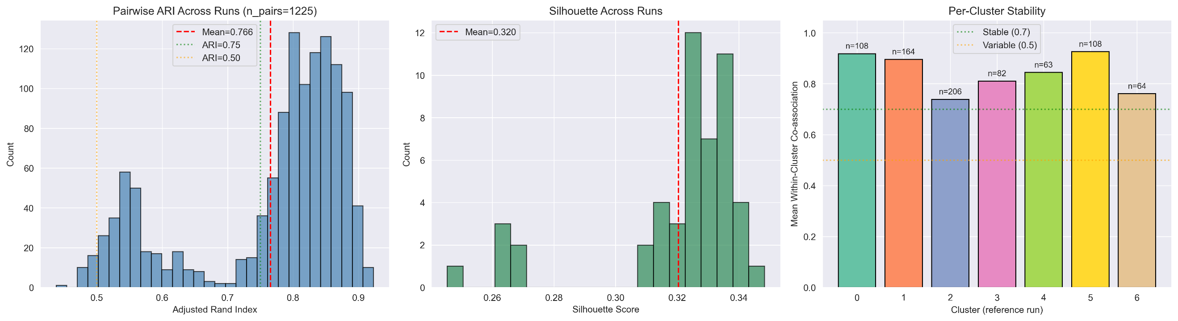
Fig. 2. Cluster stability (pairwise ARI, silhouette scores across runs, per-cluster stability)
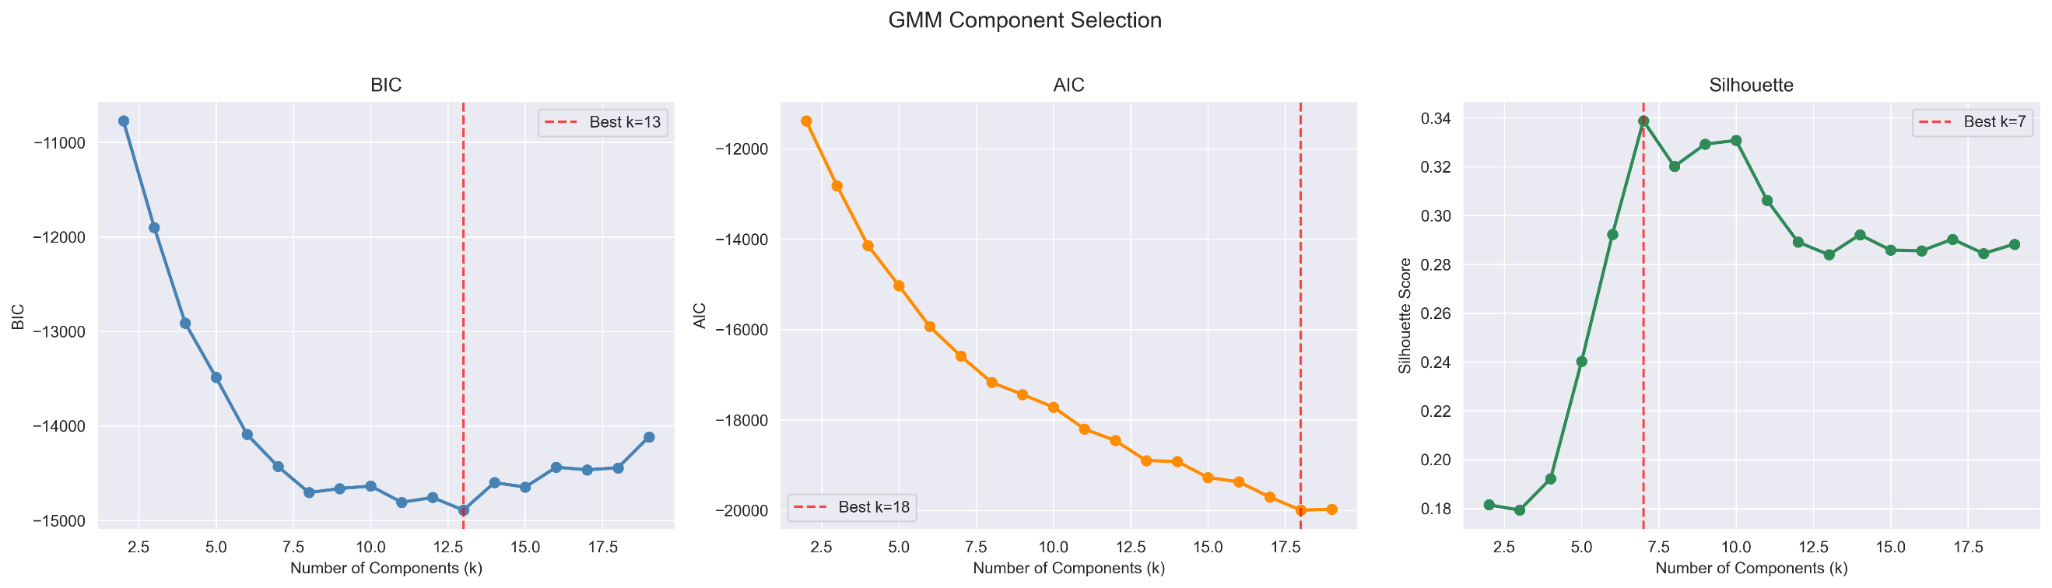
Fig. 1. GMM Component Selection
Clusters were determined to be stable across 50 seeds using Adjusted Rand Indexing (ARI) and Normalized Mutual Information (NMI) between seeds and the reference seed. Additionally, pairwise ARI and NMI were calculated to ensure that respondents were grouped into similar clusters across seeds.

Table 1. Cluster stability metrics across 50 random seeds
Metric | Mean | Standard Deviation
ARI vs. Reference | 0.797 | 0.090
NMI vs. Reference | 0.819 | 0.064
Silhouette Score | 0.320 | 0.023
Pairwise ARI | 0.766 | 0.122
Pairwise NMI | 0.799 | 0.081
Per-Cluster Stability
Cluster 0 | 0.926
Cluster 1 | 0.918
Cluster 2 | 0.895
Cluster 3 | 0.844
Cluster 4 | 0.810
Cluster 5 | 0.760
Cluster 6 | 0.739

As can be seen in Table 1 and Fig. 2, all of the clusters maintained stability throughout each seed and had within-cluster co-association higher than 0.7 and silhouette scores remained stable with a mean of 0.320.
When visualizing the clusters from the reference seed, one can see that there are clear delineations between the clusters with defined boundaries, with one cluster far from the rest, indicating that the clusters found via UMAP/GMM are significant. Figure 3 shows the separation of the clusters and each respondent’s assignment confidence.
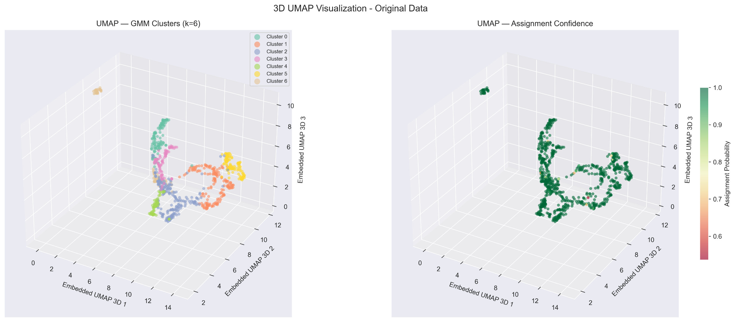
Fig. 3. 3D UMAP visualization (embedded data)
B. Cluster Identification and Phenotyping
A Z-score heatmap with dendrograms was used to determine phenotypical characteristics of each cluster and their similarities to each other. The results showed that each cluster had identifiable characteristics that separated them from each other, with the exception of Clusters 1 and 2, which stratified based on both sex and features that are highly correlated with sex, like height, Vitamin D, and HDL, indicating that sex is a significant determiner for the mild, controlled HbA1c subset.
Features with Z-scores in clusters higher than the rest of the cohort were used to label each cluster and assign phenotypes to the clusters. These phenotypes included biomarkers, lifestyle descriptions, and demographics. The clustering names and defining characteristics are as follows and are shown in Figure 4:
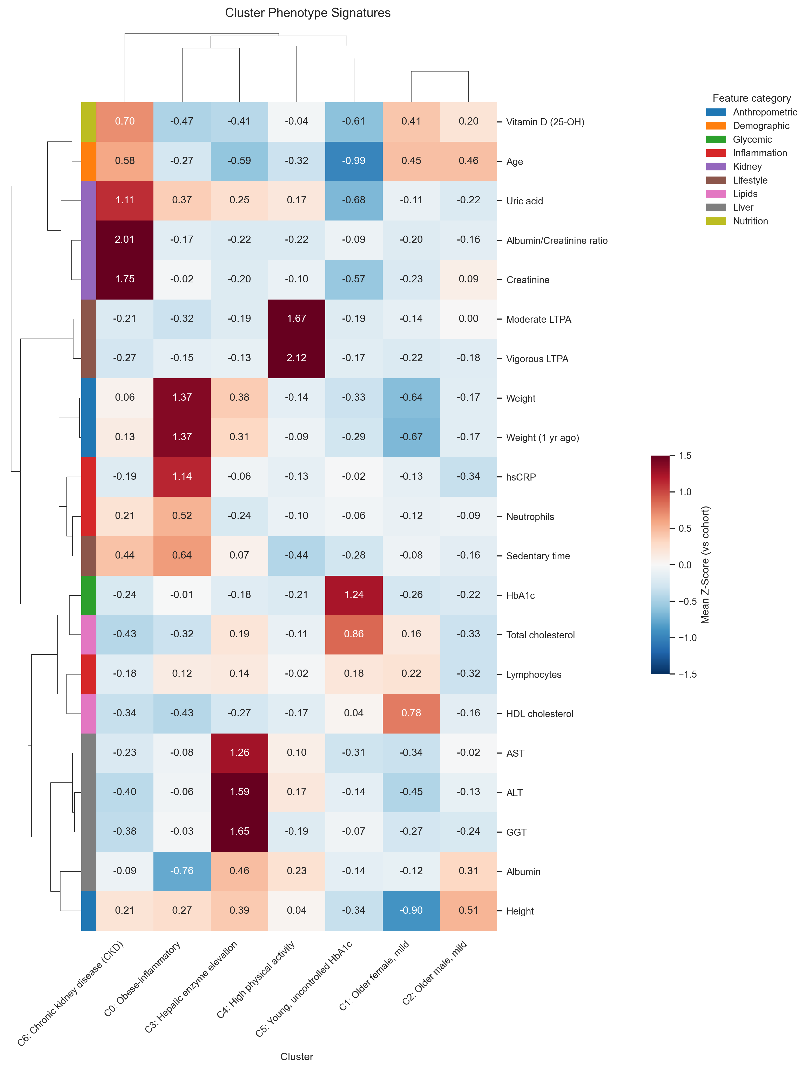
Fig. 4. Cluster phenotype signatures Z-score heatmap

Table 2. Cluster phenotypes
Cluster | Characteristics
Cluster 0 (C0) | Obese-inflammatory
Cluster 1 (C1) | Older female, mild
Cluster 2 (C2) | Older male, mild
Cluster 3 (C3) | Hepatic enzyme elevation
Cluster 4 (C4) | High physical activity
Cluster 5 (C5) | Young, uncontrolled HbA1c
Cluster 6 (C6) | Chronic kidney disease (CKD)

As previously stated, Clusters 1 and 2 were gender stratified but statistically different enough to warrant their own clusters. Women typically have higher HDL cholesterol than men, are shorter on average, weigh less, and have higher Vitamin D levels, represented in the heatmap in Fig. 4. One discriminative feature, however, is the albumin levels in Cluster 2.
Clusters 0, 1, 2, 5, and 6 mapped cleanly to Ahlqvist et al.’s original clusters: Cluster 0 could be mapped to Mild Obesity-Related Diabetes (MOD), Clusters 1 and 2 could be mapped to Mild Age-Related Diabetes (MARD), Cluster 5 could be mapped to Severe Insulin-Deficient Diabetes (SIDD), and Cluster 6 could be mapped to Severe Insulin-Resistant Diabetes (SIRD). However, this study did not have access to HOMA-IR data so a direct comparison to Ahlqvist et al. could not be made for Cluster 6 [2].
The two novel phenotypes that resulted from this study are those in Clusters 3 and 4, namely phenotypes related to physical activity and elevated hepatic (liver) enzymes. Ahlqvist et al. did not use lifestyle surveys, lipid panel tests, or liver function tests, and instead relied on GAD antibodies, Age at diagnosis, BMI, HbA1c, HOMA-B, and HOMA-IR. This limitation would not have allowed Ahlqvist et al. to identify subsets of persons with diabetes related to exercise or hepatic function, both of which could be clinically meaningful in terms of treatment and progression. Cluster 4, characterized by high amounts of physical activity, had either lower than average or close to average test results and responses for almost all remaining features, save for albumin, uric acid, AST, and ALT, which were slightly above average. Cluster 3 represents a novel diabetes phenotype in which respondents had much higher hepatic function enzymes than the rest of the cohort, higher albumin, and slightly higher weight, but were typically younger than the rest of the cohort. This finding could help lead researchers and clinicians to develop targeted treatment plans and care choices specific to this phenotype.

C. Decision Tree and XGBoost Models
As stated previously, a Decision Tree and an XGBoost model were both fit to the unscaled, imputed data and cluster assignments to allow for direct analysis and comparison to clinical findings. The hyperparameter-tuned and 5-fold cross-validated XGBoost model was much more accurate and metrics were calculated against a holdout set of the data. However, the Decision Tree, offers insights into the thresholds between features that distinguish one cluster from another and as such was trained on the entirety of the data for explainability and interpretation purposes. The Decision Tree structure can be found in the Appendix in Figure A1. The classification metrics for both the Decision Tree and XGBoost models are as follows:

Table 3. Decision tree model classification metrics
Cluster | Precision | Recall | F1-Score | Support
C0 | 0.62 | 0.76 | 0.68 | 108
C1 | 0.74 | 0.68 | 0.71 | 164
C2 | 0.69 | 0.65 | 0.67 | 206
C3 | 0.65 | 0.74 | 0.69 | 82
C4 | 0.67 | 0.62 | 0.64 | 63
C5 | 0.66 | 0.56 | 0.61 | 108
C6 | 0.60 | 0.67 | 0.63 | 64
accuracy |  |  | 0.67 | 795
macro average | 0.66 | 0.67 | 0.66 | 795
weighted average | 0.67 | 0.67 | 0.67 | 795

Table 4. XGBoost model classification metrics

Cluster | Precision | Recall | F1-Score | Support
C0 | 0.85 | 0.77 | 0.81 | 22
C1 | 0.68 | 0.82 | 0.74 | 33
C2 | 0.74 | 0.71 | 0.72 | 41
C3 | 0.81 | 0.81 | 0.81 | 16
C4 | 0.82 | 0.75 | 0.78 | 12
C5 | 0.83 | 0.68 | 0.75 | 22
C6 | 0.73 | 0.85 | 0.79 | 13
accuracy |  |  | 0.76 | 159
macro average | 0.78 | 0.77 | 0.77 | 159
weighted average | 0.77 | 0.76 | 0.76 | 159

D. Clinical Markers for Cluster Assignment
Shapley Additive Explanations (SHAP) values were used for model interpretability and additional insights into the decision thresholds for the XGBoost model. Due to the algorithmic and game-theory driven nature of SHAP analysis, the results will allow future clinicians and researchers alike to ascertain which features influence the determination of a cluster categorization for a respondent.
As can be seen in Fig. 5, the top features and directions of each cluster align closely with the Z-score analysis performed after cluster assignment. C0 is defined by weight, inflammation, and lower activity, C1 and 2 by sex segmented characteristics (as distinguishing features between the two), C3 by high ALT and GGT values, C4 by physical activity, C5 by age and HbA1c levels, and C6 by creatinine, albumin/creatinine ratio, Vitamin D, and uric acid.
These explanations from the SHAP analysis of the XGBoost model help to support the decision boundaries created by the UMAP/GMM modeling and add further validation to the cluster definitions.
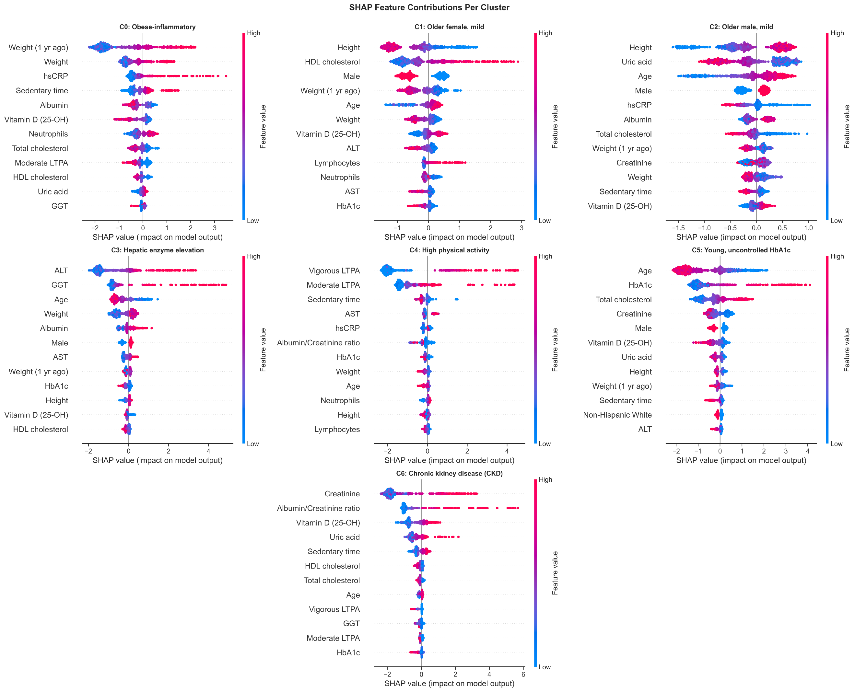
Fig. 5. SHAP feature contributions per cluster
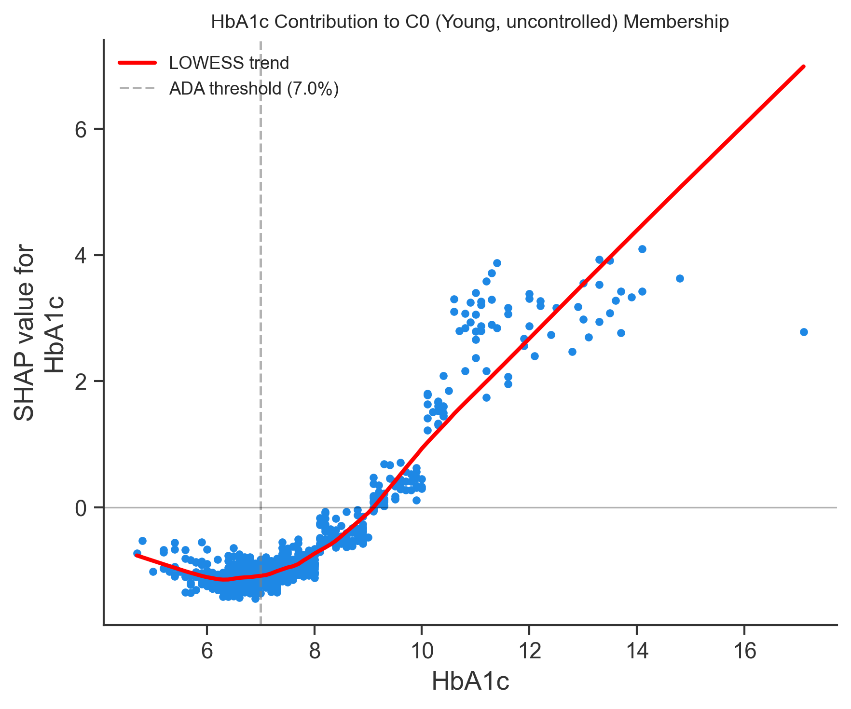
Fig. 6. HbA1c contribution to C0 (young, uncontrolled) membership
As well, to further model’s validity, the model independently learned the American Diabetes Association (ADA)’s threshold for “uncontrolled HbA1c” through the characteristics of Cluster 5, as shown in the SHAP dependence plot in Fig. 6. Uncontrolled hyperglycemia is defined as an HbA1c of 8.0% or higher [6], and the results show a steep increase in assignment for Cluster 5 starting at 8.0% for HbA1c results, demonstrating that the model independently concluded the threshold for the definition without explicit definitions.

VI. Conclusion
A. Limitations
NHANES is a self-response survey for the United States. As such, some of the survey data such as vigorous and moderate physical activity, may be skewed or incorrect in reality. As well, there were several missing values that needed to be imputed through MICE, leaving questions as to the validity of the means of these imputed features.
Another limiting factor for this study is the fact that persons with diabetes Type 1 could not be removed from the cohort due to the lack of GAD or C-peptide tests. While diabetes Type 1 accounts for roughly 5-10% of the United States diabetes population and the study was limited to individuals aged 17 and older (diabetes Type 1 is typically diagnosed in younger persons), it would still be beneficial to investigate whether the clusters found in this study apply only to diabetes Type 2 specifically or if the clusters span between Type 1 and Type 2 holistically.
A more rigorous, scoped study will need to be conducted to verify the findings as it relates to the features used in this study to account for measurement anomalies, self-reported statistics, and missing data.

B. Implications
While this study found novel phenotypes in two clusters, namely the high physical activity (Cluster 4) and hepatic enzyme elevation (Cluster 5) groups, recommendations can only be made to include their defining features in subsequent research or clinical trials, and implications cannot be made concerning clinical usage until more rigorous and controlled longitudinal studies have been performed, specifically in relation to treatment options and clinical care.
With that, the findings of this study supported the hypothesis proposed Ahlqvist et al. that diabetes is not a monolithic, homogenous disease but is rather heterogenous and is comprised of sub-groups that each exhibit their own phenotypical characteristics and may need specialized treatments and progression analyses [2]. This study furthered the argument for sub-groups by introducing lifestyle, demographic, and physical activity survey responses, as well as lipid, hepatic enzyme, and renal function panels to provide a broader representation of individuals and address diabetes comorbidities.
Past studies related to diabetes phenotyping relied heavily on k-means clustering and hierarchical analysis. This study improves upon the methodology of previous studies by increasing rigor and utilizing UMAP and GMM algorithms with multi-seed verification, followed by explainable machine learning techniques using a Decision Tree, XGBoost, and SHAP analysis. These sequential techniques ensured that the results were valid, repeatable, and explainable.
By examining a more holistic view of individuals, two novel phenotype groups were uncovered through UMAP/GMM clustering, supporting the need for more studies that include a comprehensive view of persons with diabetes beyond standard biomarkers.
References

[1] American Diabetes Association Professional Practice Committee, "2. Diagnosis and Classification of Diabetes: Standards of Care in Diabetes—2026," Diabetes Care, vol. 49, no. Suppl. 1, Jan. 2026,
doi: 10.2337/dc26-S002.
[2] E. Ahlqvist et al., "Novel subgroups of adult-onset diabetes and their association with outcomes: a data-driven cluster analysis of six variables," The Lancet Diabetes & Endocrinol., vol. 6, no. 5, pp. 361-369, May 2018.
[3] Centers for Disease Control and Prevention, "National Diabetes Statistics Report," U.S. Department of Health and Human Services, Atlanta, GA, 2026. [Online].
Available:https://www.cdc.gov/diabetes/php/data-research/index.html. Accessed: Mar. 16, 2026.
[4] W. K. Chung et al., "Precision medicine in diabetes: A consensus report from the American Diabetes Association (ADA) and the European Association for the Study of Diabetes (EASD)," Diabetes Care, vol. 43, no. 7, pp. 1617-1635, Jul. 2020.
[5] S. Misra et al., "Precision subclassification of type 2 diabetes: a systematic review," Commun. Med., vol. 3, no. 1, p. 139, Sep. 2023.
[6] Liu, Longjian et al. “Burden of Uncontrolled Hyperglycemia and Its Association with Patients Characteristics and Socioeconomic Status in Philadelphia, USA.” Health equity vol. 4,1 525-532. 30 Dec. 2020, doi:10.1089/heq.2020.0076
Appendix
Table A1. Descriptive statistics by cluster phenotype. Continuous features are reported as mean (standard deviation); binary variables as count (%), p-values from Kruskal-Wallis tests for continuous variables and chi-square tests for binary variables, with α = 0.05.
Feature | Overall | C0: Obese-inflammatory | C1: Older female, mild | C2: Older male, mild | C3: Hepatic enzyme elevation | C4: High physical activity | C5: Young, uncontrolled HbA1c | C6: Chronic kidney disease (CKD) | p-value
n | 795 | 108 | 164 | 206 | 82 | 63 | 108 | 64
Albumin/Creatinine ratio | 63.17 (176.38) | 32.73 (44.53) | 28.66 (49.34) | 34.63 (55.67) | 24.53 (29.44) | 23.93 (45.98) | 46.82 (70.64) | 417.10 (478.29) | <0.0001
ALT | 23.54 (13.88) | 22.68 (9.89) | 17.23 (6.82) | 21.75 (9.39) | 45.65 (20.41) | 25.95 (13.57) | 21.56 (10.55) | 18.00 (10.76) | <0.0001
Albumin | 3.96 (0.33) | 3.71 (0.25) | 3.92 (0.36) | 4.06 (0.28) | 4.11 (0.32) | 4.03 (0.27) | 3.91 (0.31) | 3.93 (0.32) | <0.0001
AST | 22.15 (9.46) | 21.40 (7.80) | 18.95 (4.96) | 21.99 (8.05) | 34.06 (14.99) | 23.07 (8.76) | 19.18 (7.26) | 19.93 (6.61) | <0.0001
Creatinine | 0.95 (0.41) | 0.94 (0.30) | 0.85 (0.24) | 0.99 (0.26) | 0.86 (0.20) | 0.91 (0.23) | 0.71 (0.20) | 1.67 (0.95) | <0.0001
GGT | 36.12 (34.79) | 35.05 (22.93) | 26.63 (17.43) | 27.76 (17.10) | 93.53 (68.84) | 29.60 (17.77) | 33.75 (20.37) | 22.88 (12.01) | <0.0001
Uric acid | 5.34 (1.56) | 5.91 (1.40) | 5.17 (1.39) | 5.00 (1.25) | 5.74 (1.68) | 5.60 (1.32) | 4.28 (1.25) | 7.07 (1.90) | <0.0001
Lymphocytes | 2.13 (0.83) | 2.23 (0.74) | 2.31 (1.05) | 1.86 (0.64) | 2.25 (0.89) | 2.11 (0.83) | 2.28 (0.64) | 1.98 (0.83) | <0.0001
Neutrophils | 4.50 (1.65) | 5.36 (1.71) | 4.31 (1.66) | 4.35 (1.88) | 4.12 (1.32) | 4.34 (1.37) | 4.41 (1.24) | 4.86 (1.39) | <0.0001
HbA1c | 7.67 (1.66) | 7.65 (1.42) | 7.23 (1.07) | 7.29 (1.12) | 7.36 (1.33) | 7.31 (1.22) | 9.72 (2.56) | 7.26 (0.96) | <0.0001
HDL cholesterol | 47.97 (12.43) | 42.62 (8.63) | 57.71 (16.10) | 46.02 (9.44) | 44.63 (9.41) | 45.90 (9.53) | 48.47 (12.13) | 43.68 (8.10) | <0.0001
hsCRP | 4.62 (5.70) | 11.12 (10.27) | 3.87 (4.33) | 2.68 (2.80) | 4.26 (3.89) | 3.89 (4.08) | 4.50 (3.90) | 3.55 (3.47) | <0.0001
Total cholesterol | 174.21 (46.24) | 159.28 (38.15) | 181.61 (43.88) | 159.17 (35.17) | 183.07 (48.72) | 169.20 (42.05) | 214.03 (54.94) | 154.21 (32.02) | <0.0001
Vitamin D (25-OH) | 82.33 (39.87) | 63.77 (28.09) | 98.72 (44.27) | 90.35 (38.25) | 65.78 (29.89) | 80.60 (38.03) | 57.82 (24.97) | 110.09 (39.51) | <0.0001
Height | 66.38 (4.40) | 67.56 (4.26) | 62.41 (3.43) | 68.61 (3.30) | 68.10 (3.56) | 66.57 (3.43) | 64.88 (4.40) | 67.30 (4.39) | <0.0001
Weight | 201.46 (50.14) | 270.38 (46.77) | 169.25 (35.75) | 193.18 (36.78) | 220.61 (39.02) | 194.35 (41.86) | 185.14 (42.85) | 204.61 (38.45) | <0.0001
Weight (1 yr ago) | 205.96 (53.08) | 278.79 (50.81) | 170.40 (36.32) | 196.86 (38.49) | 222.29 (38.29) | 200.98 (44.42) | 190.66 (46.66) | 212.70 (42.43) | <0.0001
Age | 63.21 (12.07) | 59.97 (12.27) | 68.60 (8.97) | 68.71 (8.28) | 56.07 (11.29) | 59.33 (11.24) | 51.31 (11.39) | 70.23 (8.54) | <0.0001
Sedentary time | 373.67 (215.93) | 511.96 (256.99) | 357.42 (207.33) | 339.22 (174.95) | 389.27 (227.30) | 278.41 (205.62) | 312.21 (170.63) | 468.75 (210.81) | <0.0001
Moderate LTPA | 145.86 (222.98) | 74.91 (134.03) | 115.48 (139.90) | 146.40 (139.11) | 103.91 (109.41) | 519.02 (509.56) | 103.59 (132.42) | 98.19 (146.14) | <0.0001
Vigorous LTPA | 30.63 (92.01) | 17.05 (50.37) | 10.28 (31.58) | 14.35 (34.52) | 19.11 (44.78) | 225.76 (221.95) | 14.96 (32.76) | 5.81 (29.06) | <0.0001
Diagnosed with hypertension | 533/794 (67%) | 84/108 (78%) | 116/164 (71%) | 133/206 (65%) | 48/82 (59%) | 38/62 (61%) | 56/108 (52%) | 58/64 (91%) | <0.0001
Diagnosed High Blood Cholesterol | 535/783 (68%) | 68/108 (63%) | 115/161 (71%) | 145/202 (72%) | 47/81 (58%) | 36/62 (58%) | 70/106 (66%) | 54/63 (86%) | 0.0037
Taking cholesterol medication | 502/787 (64%) | 64/107 (60%) | 111/164 (68%) | 150/203 (74%) | 45/81 (56%) | 31/63 (49%) | 48/107 (45%) | 53/62 (85%) | <0.0001
Taking insulin | 221/575 (38%) | 37/79 (47%) | 35/114 (31%) | 47/159 (30%) | 15/45 (33%) | 14/40 (35%) | 39/80 (49%) | 34/58 (59%) | 0.0004
Taking Diabetic Oral Agents | 475/698 (68%) | 67/94 (71%) | 101/143 (71%) | 132/191 (69%) | 36/63 (57%) | 35/51 (69%) | 62/94 (66%) | 42/62 (68%) | 0.5916
Diagnosed failing kidneys | 72/793 (9%) | 9/108 (8%) | 13/164 (8%) | 11/206 (5%) | 2/81 (2%) | 4/63 (6%) | 4/107 (4%) | 29/64 (45%) | NA
Tried to Lose Weight (12 Months) | 388/795 (49%) | 70/108 (65%) | 79/164 (48%) | 84/206 (41%) | 43/82 (52%) | 33/63 (52%) | 48/108 (44%) | 31/64 (48%) | 0.0062
Prepares Meals | 551/795 (69%) | 77/108 (71%) | 132/164 (80%) | 116/206 (56%) | 56/82 (68%) | 49/63 (78%) | 79/108 (73%) | 42/64 (66%) | <0.0001
Shares in Preparing Meals | 401/795 (50%) | 62/108 (57%) | 67/164 (41%) | 108/206 (52%) | 44/82 (54%) | 32/63 (51%) | 54/108 (50%) | 34/64 (53%) | 0.1743
Does food shopping | 541/795 (68%) | 70/108 (65%) | 120/164 (73%) | 124/206 (60%) | 59/82 (72%) | 50/63 (79%) | 80/108 (74%) | 38/64 (59%) | 0.0107
Shares in food shopping | 412/795 (52%) | 57/108 (53%) | 77/164 (47%) | 113/206 (55%) | 44/82 (54%) | 33/63 (52%) | 53/108 (49%) | 35/64 (55%) | 0.8073
*cells with expected count <5; chi-square test not applicable

